Test automation FRAMEWORK

Selenium TestNG Framework is a code structure that helps to make code maintenance easy. Without frameworks, we will place the “code” as well as “data” in the same place which is neither re-usable nor readable. Using Frameworks, produce beneficial outcomes like increased code re-usage, higher portability, reduced script maintenance cost, higher code readability, etc.
When creating a Test Automation Framework, we should consider the following main points:
- To be able to create automated tests quickly by using appropriate abstraction layers
- The framework should have meaningful logging and reporting structure
- Should be easily maintainable and extendable
- Should be simple enough for testers to write automated tests
- A retry mechanism to rerun failed tests – this is especially useful for WebDriver UI tests

TYPES OF TEST AUTOMATION FRAMEWORKS
There are several test automation frameworks available, among these the selection is made based on the factors such as reusability of both the scripts and the test assets. The different test automation frameworks available are as follows,
  - Test Script Modularity
  - Test Library Architecture
  - Data-Driven Testing
  - Keyword-Driven or Table-Driven Testing
  - Page Object Model
  - Hybrid Test Automation
Data-Driven Testing
A data-driven framework is where test input and output values are read from data files (ODBC sources, CVS files, Excel files, DAO objects, ADO objects, and such) and are loaded into variables in captured or manually coded scripts. In this framework, variables are used for both input values and output verification values. Navigation through the program, reading of the data files, and logging of test status and information are all coded in the test script. This is similar to table-driven testing (which is discussed shortly) in that the test case is contained in the data file and not in the script; the script is just a "driver," or delivery mechanism, for the data. In data-driven testing, only test data is contained in the data files.

Page Object Model(POM)
Page Object Model is a design pattern to create Object Repository for web UI elements. Under this model, for each web page in the application, there should be corresponding page class. This Page class will find the WebElements of that web page and also contains Page methods which perform operations on those WebElements.
The chief problem with script maintenance is that if 10 different scripts are using the same page element, with any change in that element, you need to change all 10 scripts. This is time consuming and error prone.
A better approach to script maintenance is to create a separate class file which would find web elements, fill them or verify them. This class can be reused in all the scripts using that element. In future, if there is a change in the web element, we need to make the change in just 1 class file and not 10 different scripts.
This approach is called Page Object Model(POM). It helps make the code more readable, maintainable, and reusable.

Hybrid Test Automation Framework
The most commonly implemented framework is a combination of all of the above techniques, pulling from their strengths and trying to mitigate their weaknesses. This hybrid test automation framework is what most frameworks evolve into over time and multiple projects. We are using both POM as well as Data-Driven scripts.
This allows data driven scripts to take advantage of the powerful libraries and utilities of the design architecture. The framework utilities can make the data driven scripts more compact and less prone to failure than they otherwise would have been.

Our Test Automation Framework is a
Hybrid Test Automation Framework

Technologies Used:
- Java as the programming language
- TestNG as the assertion framework
- Maven as the build tool
- WebDriver as the browser automation tool
- Eclipse as the IDE
- GitHub as the Version Control tool
- Jenkins as the Continuous Integration(CI/CD) tool
Hybrid Test Automation Framework Architecture:
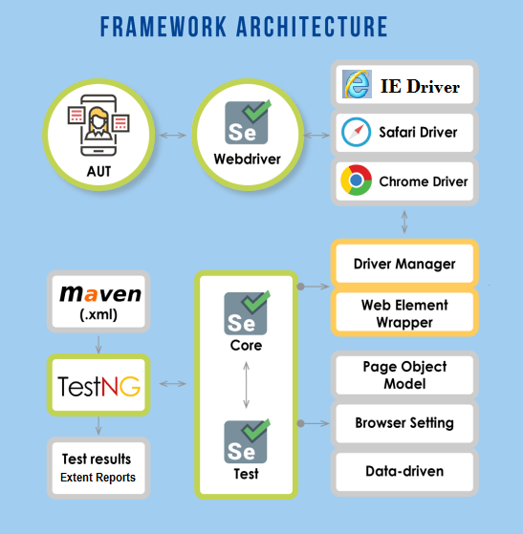
The framework is defined by the Core Data Driven Engine, the Component Functions, and the Support Libraries. While the Support Libraries provide generic routines useful even outside the context of the framework, the core engine and component functions are highly dependent on the existence of all three elements.
The test execution starts with the LAUNCH TEST(1) script. This script invokes the Core Data Driven Engine by providing one or more High-Level Test Tables to CycleDriver(2). CycleDriver processes these test tables invoking the SuiteDriver(3) for each Intermediate-Level Test Table it encounters. SuiteDriver processes these intermediate-level tables invoking StepDriver(4) for each Low-Level Test Table it encounters. As StepDriver processes these low-level tables it attempts to keep the application in synch with the test. When StepDriver encounters a low-level command for a specific component, it determines what Type of component is involved and invokes the corresponding Component Function(5) module to handle the task.
The Application Map is referred to App Map. This App Map in WRAFS is the Application Map file created from GUI Map of WinRunner

All of these elements of the framework rely on the information provided in the App Map to interface or bridge the automation framework with the application being tested. The App Map is the only means by which the framework could identify the objects in the application under test. Each of these elements is described in more detail in the following sections. The following figure shows the diagrammatic representation of the Hybrid Test Automation Framework.

Hybrid Test Automation Framework

APPLICATION MAP
The Application Map is one of the most critical components, which is used for mapping the objects from names humans can recognize to a data format useful for the automation tool. For a given project it is needed to define a naming convention or specific names for each component in each window as well as a name for the window itself. Then use the Application Map to associate that name to the identification method needed by the automation tool to locate and properly manipulate the correct object in the window.
Application Map not only gives the ability to provide useful names for the objects, it also enables the scripts and keyword driven tests to have a single point of maintenance on the object identification strings. Thus, if a new version of an application changes the title of the window or label of the components or the index of an image element within it, they should not affect the test tables. The changes will require only a quick modification in one place--inside the Application Map.

COMPONENT FUNCTIONS
Component Functions are those functions that actively manipulate or interrogate component objects. In test automation framework there are different Component Function modules for each type of component that are encountered (Window, CheckBox, TextBox, Image, Link, etc,).
Component Function modules are the application-independent extensions applied to the functions already provided by the automation tool. However, unlike those provided by the tool, the extra code to help with error detection, error correction, and synchronization are added. These modules can readily use the application-specific data stored in the Application Map and test tables as necessary. In this way, these Component Functions are developed once and are used again and again by every application tested.
Another benefit from Component Functions is that they provide a layer of insulation between the application and the automation tool. Without this extra layer, changes or "enhancements" in the automation tool itself can break existing scripts and the table driven tests. Each Component Function modules will define the keywords or "action words" that are valid for the particular component type it handles.
The component Functions takes the windows name in which the component resides, the actual component name on which the action is to be performed, the values needed for performing the action and the type of action to be performed as its arguments. The Component Function keywords and their arguments define the low-level vocabulary and individual record formats will be used to develop the test tables.

TEST TABLES
The input to the framework apart from the application map are the test tables, which holds the arguments needed for the Component Functions and other information. There are three levels in which the test tables are organized, they are as follows,
- Low-Level Test Tables (or) Step Tables
- Intermediate-Level Test Tables (or) Suite Tables
- High-Level Test Tables (or) Cycle Tables.

LOW-LEVEL TEST TABLES
Low-level Test Tables or Step Tables contain the detailed step-by-step instructions of the tests. Using the object names found in the Application Map, and the vocabulary defined by the Component Functions; these tables specify what window, what component, and what action to take on the component. The columns in the Step Tables are as follows,
- Action Command
- Window Name
- Component Name
- Values Need to Perform the Specified Action
The StepDriver module is the one that initially parses and routes all low-level instructions that ultimately drive our application.

INTERMEDIATE-LEVEL TEST TABLES
Intermediate-level Test Tables or Suite Tables do not normally contain such low-level instructions. Instead, these tables typically combine Step Tables into Suites in order to perform more useful tasks. The same Step Tables may be used in many Suites. In this way the minimum numbers of Step Tables necessary are developed. Then they are organized in Suites according to the purpose and design of the tests, for maximum reusability. The columns in the Suite Tables are as follows,
- Step Table Name
- Specific Arguments to be Passed to the Step Tables
The Suite Tables are handled by the SuiteDriver module which parses each record in the Suite Table and passes each Step Table to the StepDriver module for processing.

HIGHER-LEVEL TEST TABLES
High-level Test Tables or Cycle Tables combine intermediate-level Suites into Cycles.
The Suites can be combined in different ways depending upon the testing Cycle which is efficient to execute. Each Cycle will likely specify a different type or number of tests. The columns in the Cycle Tables are as follows,
- Suite Table Name
- Specific Arguments to be Passed to the Suite Table
These Cycles are handled by the CycleDriver module which passes each Suite to SuiteDriver for processing.

CORE DATA DRIVEN ENGINE
The Core Data Driven Engine is the primary part of the framework and it has three main modules, they are as follows
- StepDriver
- SuiteDriver
- CycleDriver
CycleDriver processes Cycles, which are high-level tables listing Suites of tests to execute. CycleDriver reads each record from the Cycle Table, passing SuiteDriver each Suite Table it finds during this process. SuiteDriver processes these Suites, which are intermediate-level tables listing Step Tables to execute. SuiteDriver reads each record from the Suite Table, passing StepDriver each Step Table it finds during this process. The following figure represents the Core Data Driven Engine,

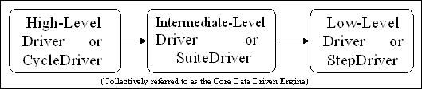
Core Data Drive Engine

StepDriver processes these Step Tables, which are records of low-level instructions developed in the keyword vocabulary of the Component Functions. StepDriver parses these records and performs some initial error detection, correction, and synchronization making certain that the window and\or the component planned to manipulate is available and active. StepDriver then routes the complete instruction record to the appropriate Component Function for final execution.

SUPPORT LIBRARIES
The Support Libraries are the general-purpose routines and utilities that let the overall automation framework do what it needs to do. They are the modules that provide services like,
- File Handling
- String Handling
- Buffer Handling
- Variable Handling
- Database Access
- Logging Utilities
- System\Environment Handling
- Application Mapping Functions
- System Messaging or System API Enhancements and Wrappers

They also provide traditional automation tool scripts access to the features of our automation framework including the Application Map functions and the keyword driven engine itself. Both of these items can vastly improve the reliability and robustness of these scripts until such time that they can be converted over to keyword driven test tables.

